1. Title
Small Office Network Design using Cisco Packet Tracer

2. Objective
The objective of this project is to design and implement a small office network using Cisco Packet Tracer. The network is divided into multiple departments using VLANs to improve organization, security, and performance. Inter-department communication is enabled using router-on-a-stick configuration. The project demonstrates practical skills in IP addressing, VLAN segmentation, and basic network troubleshooting.

3. Tools Used
Packet Tracer, Router, Switch, PCs

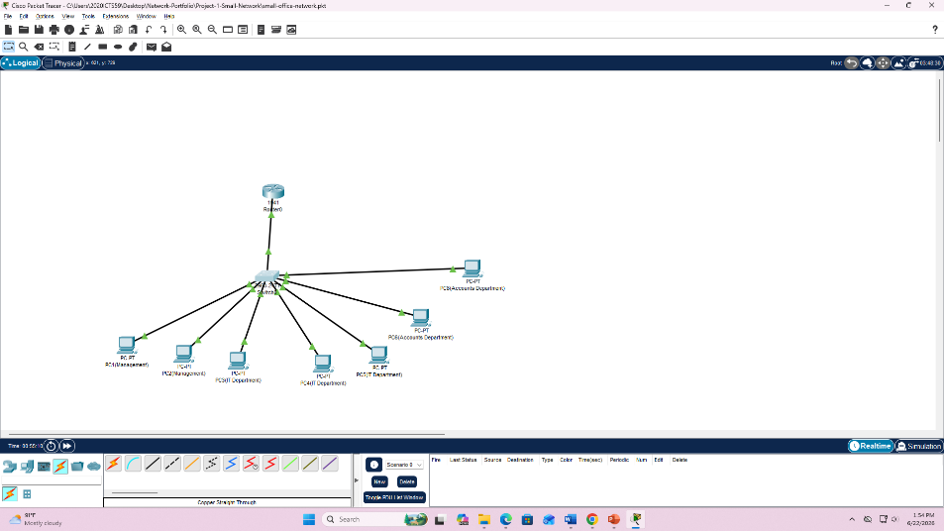
4. Network Design

5. IP Address Table
Department | Device | IP Address | Subnet Mask | Default Gateway
Management | PC1 | 192.168.10.10 | 255.255.255.0 | 192.168.10.1
Management | PC2 | 192.168.10.11 | 255.255.255.0 | 192.168.10.1
IT | PC3 | 192.168.20.10 | 255.255.255.0 | 192.168.20.1
IT | PC4 | 192.168.20.11 | 255.255.255.0 | 192.168.20.1
IT | PC5 | 192.168.20.12 | 255.255.255.0 | 192.168.20.1
Accounts | PC6 | 192.168.30.10 | 255.255.255.0 | 192.168.30.1
Accounts | PC7 | 192.168.30.11 | 255.255.255.0 | 192.168.30.1

6. VLAN Configuration
The switch was configured with three VLANs to separate departments logically:
- VLAN 10 → Management Department
- VLAN 20 → IT Department
- VLAN 30 → Accounts Department
Each switch port was assigned to the correct VLAN based on the connected department PCs. The switch-to-router connection was configured as a trunk link to allow multiple VLAN traffic.

VLAN Setup Summary:
- VLAN 10 created and assigned to Management PCs
- VLAN 20 created and assigned to IT PCs
- VLAN 30 created and assigned to Accounts PCs
- Trunk port configured between switch and router
This configuration ensures proper segmentation and controlled communication between departments.

7. Testing

✔ Testing Performed:
- Same VLAN Communication Test
  - PC1 → PC2 (Management VLAN)
  - Result: Successful reply
- IT Department Test
  - PC3 → PC4 / PC5
  - Result: Successful reply
- Accounts Department Test
  - PC6 → PC7
  - Result: Successful reply
- Inter-VLAN Communication Test
  - PC1 → PC3 (Management to IT)
  - PC1 → PC6 (Management to Accounts)
  - Result: Successful reply after router configuration

8. Conclusion
This project successfully demonstrates the design and implementation of a small office network using Cisco Packet Tracer. VLAN segmentation was used to separate departments logically, improving network organization and efficiency. Inter-VLAN routing was achieved using router-on-a-stick configuration, enabling communication between different departments. The project helped strengthen practical networking skills in VLANs, IP addressing, and troubleshooting.

